SE EXPERIMENT 5

Aim: Develop Activity and State Transition diagram for the project using any opensource tool.

- Activity Diagram
The activity diagram models the end-to-end user workflow across four system partitions (swimlanes): User/Driver, Cloud Server, Payment Gateway, and Parking Hardware.

Swimlane Description & Operational Flow:
- User / Driver: Requests parking, selects a spot, navigates to the gate, parks, and authorizes checkout payment upon departure.

- Cloud Server: Processes location data to stream spot availability, validates QR passes, and dynamically updates slot occupancy.

- Parking Hardware: Scans QR passes at gates, syncs validation requests via MQTT/HTTP, and operates entry/exit barriers.

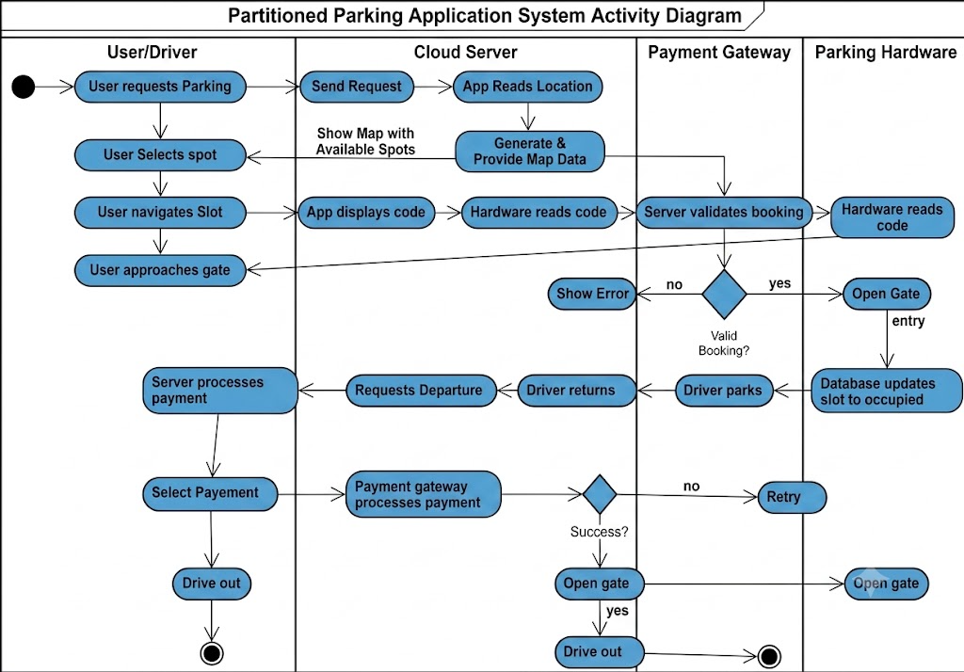
- Payment Gateway: Asynchronously processes parking fees, manages retries on failure, and issues payment confirmations.

- State Diagram
The state transition diagram models the complete operational states and event triggers of an active parking session.

State Breakdown & Transition Logic:
- System Startup & User Login: Boots from Initial State to System Idle, then shifts to Logged Out on app launch until successful login transitions to Authenticated.

- Discovery & Slot Reservation: Advances through Search Parking to Viewing Availability, moving to Booking Slot to lock a spot—looping back if unavailable or proceeding to Reservation Confirmed with a QR pass once booked.

- Navigation, Check-In & Parking: Transitions from Navigating To Parking to Parked upon valid QR scan at the barrier (or routes to System Error if rejected).

- Exit, Billing & Termination: Enters Processing Payment via exit scan, resolving to System Error on failure or Payment Successful on approval, and finally reaches Final State as the vehicle departs.
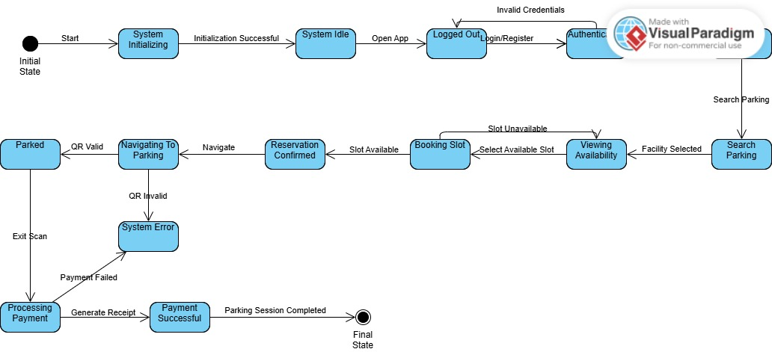

Result:
The Activity Diagram and State Transition Diagram for the Smart Parking Management System (SPMS) were successfully designed and analyzed using UML modeling tools. The diagrams effectively captured the partitioned operational workflow across actors and accurately mapped the entity state lifecycle from system initialization to checkout completion.

